Year Group: Year 4 Date 18.05.2020
 | Bronze | Silver | Gold
English | This week we will complete a series of activities based on a TV advert from 2018. If we were in school, our topic ‘Deep in the jungle’ would be well underway and we’d like to start introducing this to you now. Please watch the video https://www.youtube.com/watch?v=JdpspllWI2o you may want to watch it more than once and even watch it with a grown up. We would then like you to answer the questions on the sheet below, using your inference and comprehension skills. Remember, no one words answers! Please answer in full sentences and explain why you think that!
Maths | As so many of you enjoyed our Maths mystery challenge last week, Mr Gillespie and I have decided to give you another one this week! However, this week’s is based on a crime in a chocolate factory!!! Again, you will receive a suspect lists and one clue each day. Every day, you will be able to eliminate people from your suspect list! Good luck detectives!
Phonics/Reading | Year 3 / 4 statutory spellings.  There is a list of words that you should be able to read and spell by the end of year 4. This week, you will have a short list of these words every day. We would like you to read and then spell but using the ‘look, cover, spell, check’ strategy. If you don’t spell the word correctly please try again.
Other | Music  https://www.bbc.co.uk/bitesize/articles/zh7hnrd  Learn about pulse and rhythm by clapping and using your body.  This lesson includes:  - -two videos to help you understand pulse and rhythm  - -activities to try out

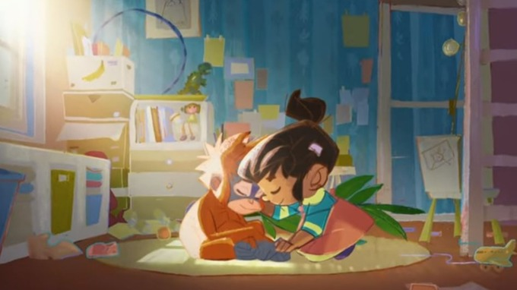
Bronze Silver Gold English
Watch the advert through together once and give the children an opportunity to ask any initial questions they might have. Then, play the advert again, pausing at appropriate points to discuss/answer/assess the questions below. Children to answer questions in their work books using full sentences which explain why they think that.
- Where is the Rang-Tan at the start of the advert?
- Can you list 3 things that the narrator tells us that the Rang-Tan keeps doing?
- Why might the Rang-Tan ‘throw’ the chocolate and ‘howl’ at the shampoo. What do these actions tell us about the animals’ feelings here?
- What word does the narrator use to describe the Rang-Tan before telling her she ‘has to go away!’
- Why does the Rang-Tan say that she was in the girl’s bedroom?
- At 32 seconds – why does the film change from colour to black and white at this moment?
- What 2 reasons are given for why humans are destroying the Rang-Tan’s trees?
- At 43 seconds – pick one word to describe how you think the Rang-Tan feels at this moment. Explain your choice of word?
- Why are human’s burning the forest?
- At 57 seconds – How do you think the girl’s feelings about the Rang-Tan in her bedroom changed? Why have they changed?
- The girl says she will ‘fight’ to save the Rang-Tan’s home. What does the word fight mean here?
- She also says she will stop the Rang-Tan ‘feeling blue.’ What does the phrase ‘feeling blue’ mean?
To finish - Talk about all the things we could do to help Orang-utans whose homes are being destroyed and lives lost.

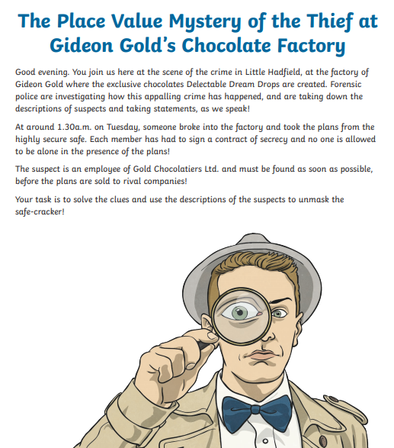
Bronze Silver Gold Maths

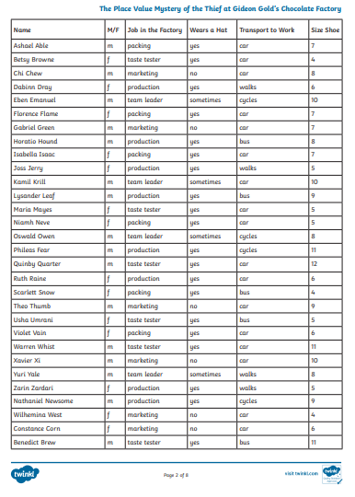

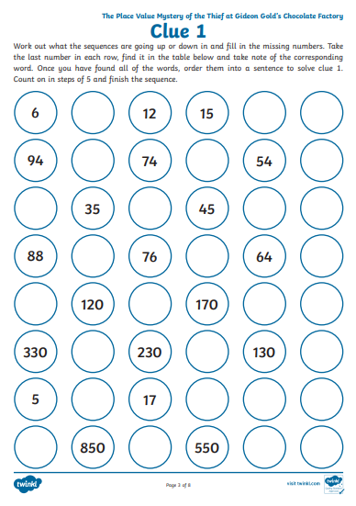

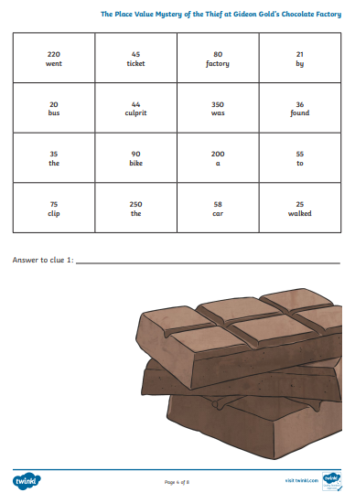

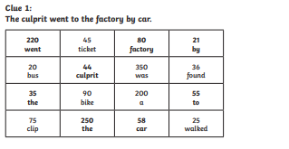
Maths Answers

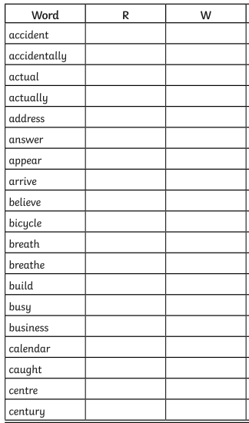
Reading/Spelling

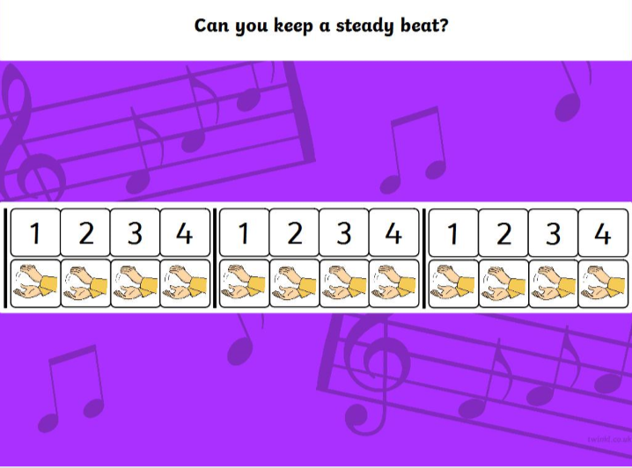
Music

