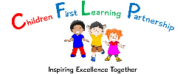

**COVID-19 Additional Behaviour Policy**

**May 2020**

**Handwashing is compulsory….**

* On arrival
* After toileting
* After each outdoor play
* Before/After Eating
* Before leaving

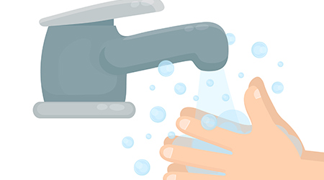

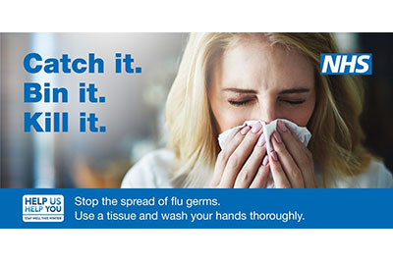

**Tissues**

* Children are encourages to use tissues to catch germs with sneezing and coughing

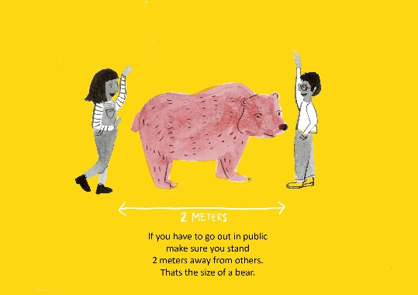

**2 metre rule**

* Staff and children must adhere to the 2 metre rule at all times both indoors and outdoors

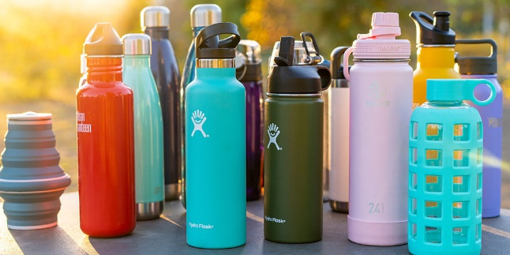

**Water bottles**

* Water bottles to be LEFT in school
* School staff to sanitise daily

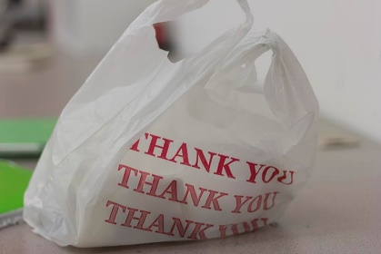

**No lunchboxes please**

* Universal free school meals are available
* However if you want to provide your own lunch then please send in a disposable plastic bag

**Clothing**

* Children to attend school in clean clothes every day.
* Uniform is not required
* Children to bring a coat each day

