Please find todays learning tasks below.
The table below explains the tasks and you will find the resources underneath. Your child will know which challenge they usually access in each subject and which task will be appropriate for them.
Year group: 3 Date: 22nd May
 | Bronze | Silver | Gold
English | Once upon a picture: Character- Please look at and use the picture to answer the questions. Remember to answer the questions in full sentences. | Once upon a picture: Inference- Please look at and use the picture to answer the questions. Remember to answer the questions in full sentences. | Pobble 365- Please look at the picture and use it to answer the questions. Remember to answer in full, clear sentences.
Maths | Please practise your multiplication and division recall by logging on to Times Tables Rockstars ( https://ttrockstars.com/) playing atleast 10 games. Remember, practise makes perfect.
Reading/Spelling | Please follow the link below to access online reading books. Please see the list of books for your child’s reading band in their red book. https://www.oxfordowl.co.uk/  Please read at least 2 pages of a book and record it in the red school links book.  Spelling test day! Ask your adult to read the questions out to you. Try your best to spell the words in your yellow book. We can’t wait to hear your scores!
Other | Today’s subject focus will be Computing. Using an art program (photoshop, paint, colour magic, drawing pad, doodle bunny), please recreate your one words calligrams from yesterday’s art lesson. If you don’t have any of these apps or programs, you can access https://pixlr.com/ for free.
Unless otherwise specified , please complete the tasks in either your homework book or on a word document
Bronze- Spellings

Spelling | Write | Write | Write
cold
gold
hold
old
told

Silver/Gold- Spellings

Spelling | Write | Write | Write
arrive

century

certain

earth

eighth

extreme

fruit

English- Bronze
The Monster’s Ring
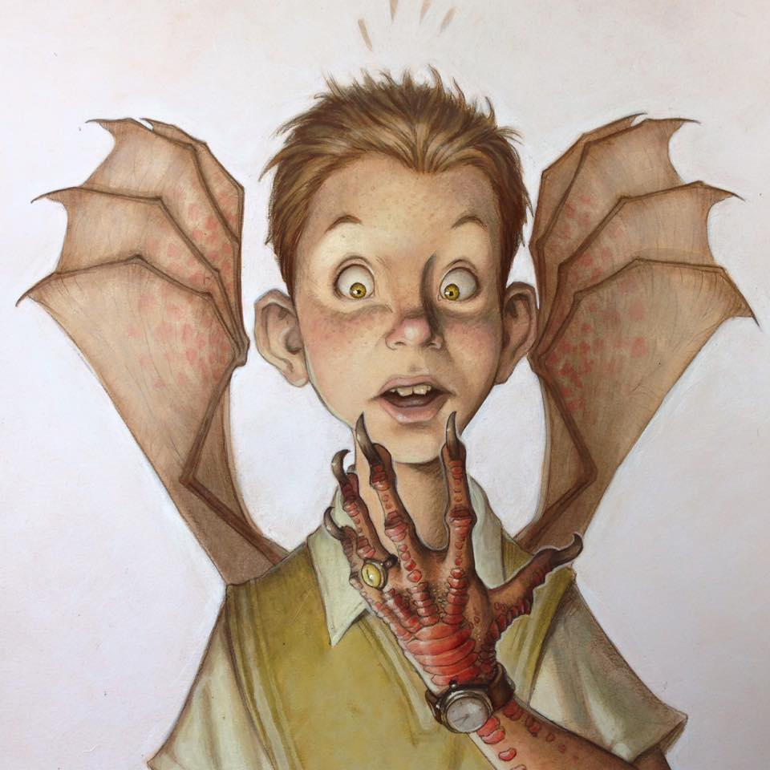
- What is ‘The Monster’s Ring’?

- Is the boy wearing it?

- What is special about it?

- What has happened to the boy?

- Which change happened first?

- Will he always be this way?

- How is he feeling?

- What might he be thinking?

English- Silver
First Flight
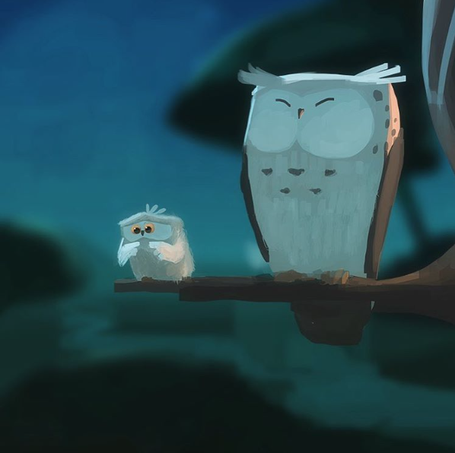

- How are the owls related?

- Which owl is about to take its first flight? How do you know?

- How does the young owl feel about flying?

- What might it be thinking? Add a thought bubble to the picture.

- Is the older owl worried?

- What advice might the older owl give to the younger one?

English- Gold

Teapots
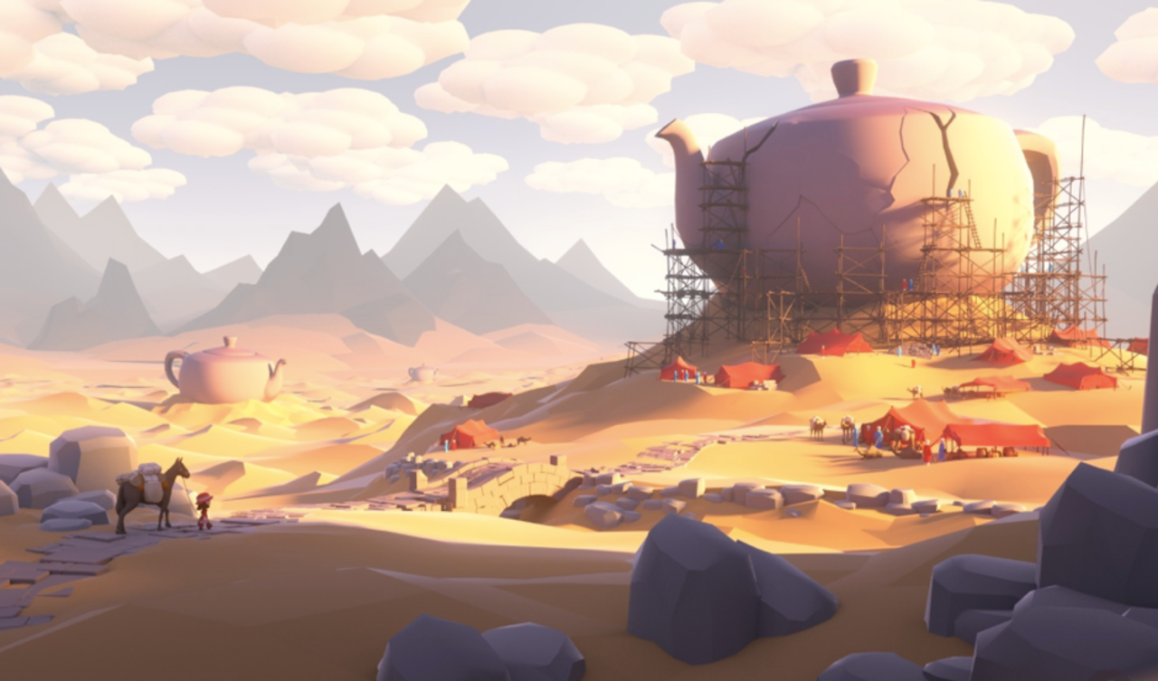

- Where have these objects come from?

- What is inside them?

- Who is Sophie and why is she so interested in these objects?

- Where has she travelled from? How did she find the teapots?

- Why have people built scaffolding up against them?

- Who are the people in the tents and why are they there?

- What do you think caused the teapots to crack?

