Please find todays learning tasks below.
The table below explains the tasks and you will find the resources underneath. Your child will know which challenge they usually access in each subject and which task will be appropriate for them.
Year group: 3 Date: 21st May
 | Bronze | Silver | Gold
English | Fronted adverbials: Today we would like you to log onto Education City, find the ‘Fronted adverbials: Bronze 21.05.20’ activity. Please watch the video and activity. Then complete the activity below. | Fronted adverbials: Today we would like you to log onto Education City, find the ‘Fronted adverbials Silver- 21.05.20’ activity. Then watch the video and activity. After complete the worksheet below. | Fronted adverbials: Today we would like you to log onto Education City, find the ‘Fronted adverbials Gold- 21.05.20’ activity. Then watch the video and activity. After use the resource sheet below to write your own sentences which begin with a fronted adverbial.
Maths | Use the number line method with remainders to solve the divisions in the 2, 5 and 10 times table. | Use the number line method with remainders to solve the divisions in the 3, 4 and 8 times table. | Use the number line method with remainders to solve the divisions in the 6, 7 and 8 times table.
Reading/Spelling | Please follow the link below to access online reading books. Please see the list of books for your child’s reading band in their red book. https://www.oxfordowl.co.uk/  Please read at least 2 pages of a book and record it in the red school links book. Can you write the common exception word 3 times? Please see the tables on the next pages. These are the words for this week. You could even test yourself on Friday. (new words will be given next Monday)  We have included a spot the spelling mistakes activity.
Other | Today’s subject focus will be Art. Using the techniques on the art page, try to create a word calligram. You will find all of the details on the art page. You will need this for tomorrow’s computing lesson.
Unless otherwise specified , please complete the tasks in either your homework book or on a word document
Bronze- Spellings

Spelling | Write | Write | Write
cold
gold
hold
old
told

Silver/Gold- Spellings

Spelling | Write | Write | Write
arrive

century

certain

earth

eighth

extreme

fruit

Bronze- Spellings
Please use the word mat on the page below to help.

Silver/Gold- Spellings
Please use the word mat on the next page to help.

English- Bronze
Please log onto Education City and find the ‘Fronted adverbials- Bronze’ activity. Watch the video and activity. Then match the fronted adverbial to the correct sentence to explain when it happens. After that add a fronted adverbial to each of the sentences.

English-Silver
Please log onto Education City and watch the video and activity. Then copy these sentences into your yellow book and add in the comma after the fronted adverbial in each sentence.

Task 1

Silver Task 2
Rewrite the following sentences into your yellow book with a fronted adverbial at the beginning of each sentence. You may use the resource sheet below the Gold work.

- The leopard gazed across the grasslands.
- The lions rested under the shade of the acacia trees.
- Stig raced towards the water hole.
- Sten drank a big glass of cold lemonade.

English- Gold
Please log on to Education City and watch the video and activity, then complete the activity below in your yellow books.

Fronted adverbials are words or phrases at the beginning of the sentence.
A comma is usually used after a fronted adverbial.

Examples:
At first, the blue and red car were neck and neck.
Without hesitation, she lapped the green car.

Task- Using the resource sheet on the next page, write your own sentences in your yellow book.
They must include a fronted adverbial and a main clause.

Gold/Silver English –Resource Sheet

Maths
Today’s focus will be using number lines to divide when there are remainders.
Using a number line to divide is the same as multiplying.
Starting at 0 make jumps of the smaller number until you get close to the big number.
When you can’t get any closer with the jumps, count the jumps and make a note of what was left over. This is the remainder.
Here is an example of how to set out your work.
19 ÷ 3 =
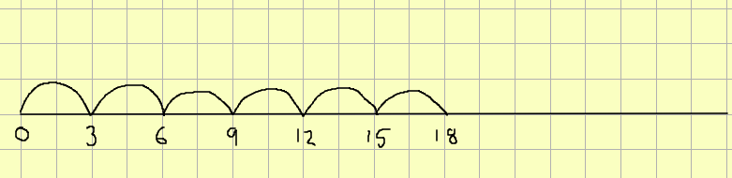
19 ÷ 3 = 6 r 1
This means 6 with a remainder of 1.
Good luck and have fun!

Maths- Bronze
- 9 ÷ 2 =
- 17 ÷ 5 =
- 34 ÷ 10 =
Maths- Silver
- 22 ÷ 3 =
- 38 ÷ 4 =
- 36 ÷ 8 =
Maths- Gold
- 42 ÷ 8 =
- 44 ÷ 7 =
- 55 ÷ 6 =

Art
Using pencils, pens and fine liners, design different styles of letters like the ones below.

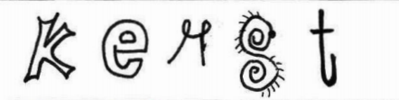

Then, use these letter styles to create one word calligrams.
Here are some examples.

