Please find todays learning tasks below.
Year group: 3 Date: 20th May
 | Bronze | Silver | Gold
English | Setting description- Today we would like you to use the key words to write a setting description. Think about your 5 senses: what would you smell, see, touch and hear? Remember to use capital letters, full stops, adjectives, 2A sentences and joined writing. | Adventure story- Today we would like you to write the rest of the story using your plan. You will need to write the problem, resolution and ending. Please see the success criteria below. Please write the story in your yellow books. | Adventure story- Today we would like you to write the rest of the story using your plan. You will need to write the problem, resolution and ending. Please see the success criteria below. Please write the story in your yellow books.
Maths | Use the number line method with chunking to solve the divisions in the 2, 5 and 10 times table. | Use the number line method with chunking to solve the divisions in the 3, 4 and 8 times table. | Use the number line method with chunking to solve the divisions in the 6, 7 and 8 times table.
Reading/Spelling | Please follow the link below to access online reading books. Please see the list of books for your child’s reading band in their red book. https://www.oxfordowl.co.uk/  Please read at least 2 pages of a book and record it in the red school links book. Can you write the common exception word 3 times? Please see the tables on the next pages. These are the words for this week. You could even test yourself on Friday. (new words will be given next Monday)  We have attached some wordsearches for you to complete.
Other | Today is it Well-being Wednesday. We would like you to do today’s activity from the well-being calendar. Stick a large piece of paper on your wall and make a mural/collage of photographs of you and your family smiling. You may do it on the computer. You could also look at the calendar and choose another activity of your choice. Enjoy1
The table below explains the tasks and you will find the resources underneath. Your child will know which challenge they usually access in each subject and which task will be appropriate for them.
Unless otherwise specified , please complete the tasks in either your homework book or on a word document
Bronze- Spellings

Spelling | Write | Write | Write
cold
gold
hold
old
told

Bronze- Spellings

Silver/Gold- Spellings

Spelling | Write | Write | Write
arrive

century

certain

earth

eighth

extreme

fruit

Silver/Gold- Spellings

English- Bronze
Setting description- Please can you use the key words below to write a setting description. Think about your 5 senses- what would you smell, see, touch and hear?
Remember to use capital letters, full stops, adjectives, 2A sentences and joined writing.

English- Silver/Gold
Retell the rest of the story of ‘Taking Flight’ in your own words. You will need to include the problem, resolution and ending. Here is the video- https://www.literacyshed.com/takingflight.html

Success Criteria
Silver | Gold
- Capital letters  - Full stops  - WOW words- adjectives  - Adverbs- -ly words  - Fronted adverbials  - Paragraphs  - Complex sentences- ad same ad sentences.  - Joined writing | - Capital letters  - Full stops  - WOW words- adjectives  - Adverbs- -ly words  - Fronted adverbials  - Similes  - Paragraphs  - Complex sentences- ad same ad sentences and noun, which, where, who sentences.  - Joined writing

Challenge- Can you include some speech in your story?

Maths
Today’s focus will be using number lines to divide.
Using a number line to divide is the same as multiplying.
Starting at 0, make a jump of the smaller number x 10. This will give you a large chunk.
Then make jumps of the small number until you get to the larger number.
Then, count the jumps.
Here is an example of how to set out your work.
48 ÷ 3 =
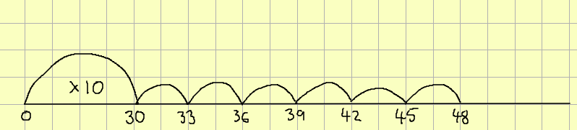
48 ÷ 3 = 16
Good luck and have fun!

Maths- Bronze
- 26 ÷ 2 =
- 70 ÷ 5 =
- 120 ÷ 10 =
Maths- Silver
- 39 ÷ 3 =
- 56 ÷ 4 =
- 96 ÷ 8 =
Maths- Gold
- 104 ÷ 8 =
- 84 ÷ 7 =
- 84 ÷ 6 =

