Please find todays learning tasks below.
The table below explains the tasks and you will find the resources underneath. Your child will know which challenge they usually access in each subject and which task will be appropriate for them.
Year group: 3 Date: 19th May
 | Bronze | Silver | Gold
English | Adventure story- Today we would like you to use your plan from yesterday to write a retell of the ‘Taking Flight’ story. Please use the pictures below to help retell the story.  Remember to use: capital letters, full stops, 2A sentences, and/but/when, different sentence starters and joined writing. | Adventure story (beginning and build up)- Today we would like you write the beginning and build up of the story ‘Taking Flight’. Please use your plan from yesterday and include everything from the success criteria below. | Adventure story (beginning and build up)- Today we would like you write the beginning and build up of the story ‘Taking Flight’. Please use your plan from yesterday and include everything from the success criteria below.
Maths | Use the number line method to solve the divisions in the 2, 5 and 10 times table. | Use the number line method to solve the divisions in the 3, 4 and 8 times table. | Use the number line method to solve the divisions in the 6, 7 and 8 times table.
Reading/Spelling | Please follow the link below to access online reading books. Please see the list of books for your child’s reading band in their red book. https://www.oxfordowl.co.uk/  Please read at least 2 pages of a book and record it in the red school links book. Can you write the common exception word 3 times? Please see the tables on the next pages. These are the words for this week. You could even test yourself on Friday. (new words will be given next Monday)  Please try the SPAG activities attached.
Other | Today’s subject focus will be Science- Today we would like you to read through the presentation about how water is transported through the plant. We would then like you to carry out the plant investigation and record your results in the table provided below. Please send us some photos of your investigation.
Unless otherwise specified , please complete the tasks in either your homework book or on a word document
Bronze- Spellings

Spelling | Write | Write | Write
cold
gold
hold
old
told

Silver/Gold- Spellings

Spelling | Write | Write | Write
arrive

century

certain

earth

eighth

extreme

fruit

SPAG- Bronze

SPAG- Silver

SPAG- Gold

English- Bronze
Please use these pictures to help retell the story of ‘Taking Flight’. Here is the video- https://www.literacyshed.com/takingflight.html

English- Silver/Gold
Retell the beginning and build up of the story of ‘Taking Flight’ in your own words. Here is the video- https://www.literacyshed.com/takingflight.html

Success Criteria
Silver | Gold
- Capital letters  - Full stops  - WOW words- adjectives  - Adverb- -ly words  - Fronted adverbials  - Paragraphs  - Complex sentences- ad same ad sentences.  - Joined writing | - Capital letters  - Full stops  - WOW words- adjectives  - Adverbs- -ly words  - Fronted adverbials  - Similes  - Paragraphs  - Complex sentences- ad same ad sentences and noun, which, where, who sentences.  - Joined writing

Maths
Today’s focus will be using number lines to divide.
Using a number line to divide is the same as multiplying.
Starting at 0, make jumps of the smaller number until you get to the larger number, Then, count the jumps.
Here is an example of how to set out your work.
18 ÷ 3 =
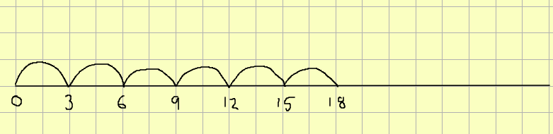
18 ÷ 3 = 6
Good luck and have fun!

Maths- Bronze
- 20 ÷ 5 =
- 14 ÷ 2 =
- 60 ÷ 10 =
Maths- Silver
- 21 ÷ 3 =
- 32 ÷ 4 =
- 56 ÷ 8 =
Maths- Gold
- 72 ÷ 8 =
- 49 ÷ 7 =
- 42 ÷ 6 =

Science- Plant Investigation
Today we would like you to read through the powerpoint which we have attached to today’s email. We would like you to carry out the following investigation and record your results in the table on the next page. Instead of beakers you could use bottles or cups.

Science- Investigation results and conclusion.

