Please find todays learning tasks below.
The table below explains the tasks and you will find the resources underneath. Your child will know which challenge they usually access in each subject and which task will be appropriate for them.
Year group: 3 Date: 15th May
 | Bronze | Silver | Gold
English | Once upon a picture: Prediction- Please look at and use the picture to answer the questions. Remember to answer the questions in full sentences. | Once upon a picture: Inference- Please look at and use the picture to answer the questions. Remember to answer the questions in full sentences. | Pobble 365- Please look at the picture and use it to answer the questions. Remember to answer in full, clear sentences.
Maths | Please complete the * mental maths questions.  Now test your times table following your practise yesterday – remember you only have 6 seconds to answer each questions. | Please complete the ** mental maths questions.  Now test your times table following your practise yesterday – remember you only have 6 seconds to answer each questions. | Please complete the *** mental maths questions.  Now test your times table following your practise yesterday – remember you only have 6 seconds to answer each questions.
Reading/Spelling | Please follow the link below to access online reading books. Please see the list of books for your child’s reading band in their red book. https://www.oxfordowl.co.uk/  Please read at least 2 pages of a book and record it in the red school links book.  Spelling test day! Ask your adult to read the questions out to you. Try your best to spell the words in your yellow book. We can’t wait to hear your scores!
Other | Today’s subject focus will be Computing. Go to https://scratch.mit.edu/projects/editor/?tutorial=all and choose the “Animate a name” tutorial. Be as creative as you can and if you want to share your creation, go to “File” -> “Save to your computer” and then send in the file by email. That way we can look at the code and the result.
Unless otherwise specified , please complete the tasks in either your homework book or on a word document
Bronze- Spellings

Spelling | Write | Write | Write
find
kind
mind
behind
wild

Silver/Gold- Spellings

Spelling | Write | Write | Write
accident

business

centre

early

experiment

group

imagine

English- Bronze
UFO
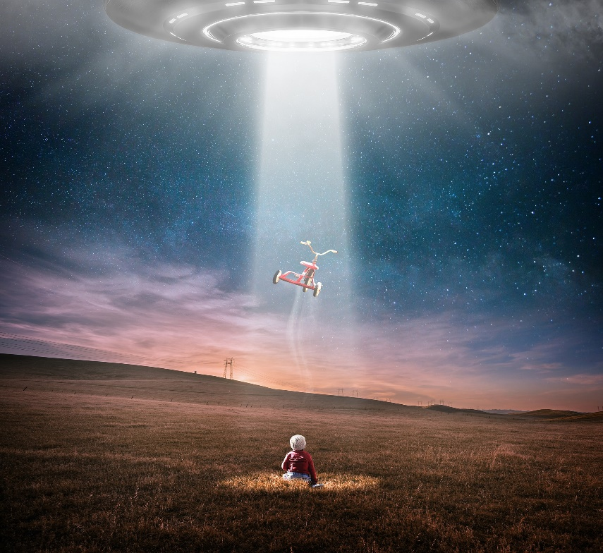

- Where did the UFO come from?
- Who or what is controlling it?
- Why are they taking the tricycle?
- Who does the tricycle belong to?
- Why was the child here alone?
- How is the child feeling?
- What will happen next?

English- Silver

Evacuation
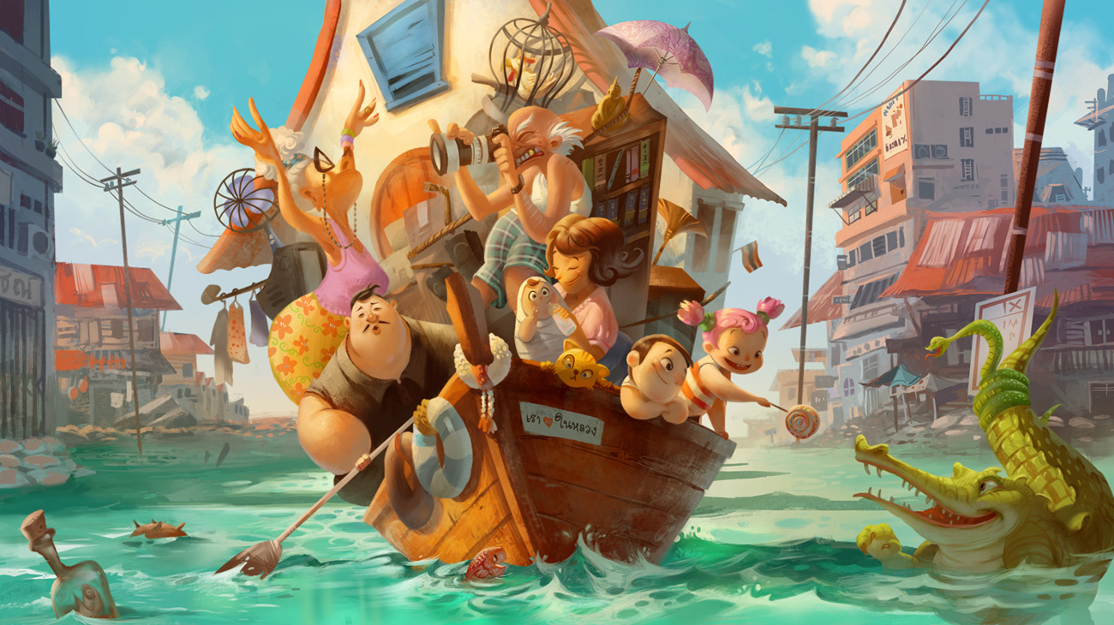

- Why are all of these people on the boat?
- What has happened?
- How do they feel about it?
- How did they manage to get so much onto the boat (including a house!)?
- Where do you think this is? Why?
- Why aren’t there any other boats?

English- Gold
Fairytale Ending
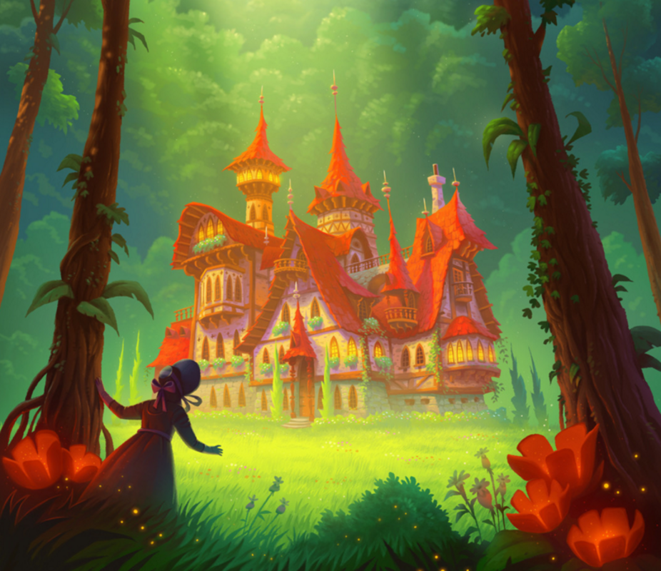

- Who is the girl in the picture?
- Where has she come from?
- What stories have been told in her village for centuries?
- What do you think she hopes will be inside the house?
- What will she actually find inside?
- Why is she all alone?
- What are the golden specks of light that appear at the front of the picture?
- How has the girl found this place?

