Please find todays learning tasks below.
The table below explains the tasks and you will find the resources underneath. Your child will know which challenge they usually access in each subject and which task will be appropriate for them.
Year group: 3 Date: 14th May
 | Bronze | Silver | Gold
English | Sentence writing- Today we would like you to look at the picture below. Please write sentences about the picture. Remember to use capital letters, full stops, 2A sentences and re-read your sentences. | Apostrophes- Today we would like you to log into Education City and find Apostrophes Silver- 14.05.20. Please then complete the activity below or online. | Apostrophes- Today we would like you to watch the video which explains what apostrophes are. Log onto Education City to find the video under Apostrophes Gold- 14.05.20. Then complete the activity below.
Maths | Use the website to create a bar chart/bar graph of the given information. | Use the website or Microsoft Excel to create a bar chart/bar graph of the given information. | Use the website or Microsoft Excel to create a bar chart/bar graph of the given information. The numbers here are quite big so we recommend using Excel if you can.
Reading/Spelling | Please follow the link below to access online reading books. Please see the list of books for your child’s reading band in their red book. https://www.oxfordowl.co.uk/  Please read at least 2 pages of a book and record it in the red school links book. Can you write the common exception word 3 times? Please see the tables on the next pages. These are the words for this week. You could even test yourself on Friday. (new words will be given next Monday)  We have included a spot the spelling mistake activity.
Other | Today’s subject focus will be Science. Please watch the video at https://www.youtube.com/watch?v=tkFPyue5X3Q and then create a poster to show the plant life cycle.
Unless otherwise specified , please complete the tasks in either your homework book or on a word document
Bronze- Spellings

Spelling | Write | Write | Write
find
kind
mind
behind
wild

Silver/Gold- Spellings

Spelling | Write | Write | Write
accident

business

centre

early

experiment

group

imagine

Bronze- Spellings
Please use the word mat on the page below to help.

Silver/Gold- Spellings
Please use the word mat on the next page to help.

English- Bronze

English- Silver Page 1

English- Page 2
Please write 2 of your own sentences with possessive apostrophes in them.

English- Gold
Watch the video on Education City and re-rewrite these sentences with the apostrophes in the correct place. Please write the sentences in your yellow book.

1. The clown had not turned up for the childrens party.
2. Clara had borrowed Rebeccas pencil without asking.
3. The babies bottles were all being cleaned at lunchtime.
4. The volcanoes craters were rocky and steamy.
5. The bananas skin was brown and bruised.
6. The giraffes neck is incredibly long so it can reach the top of trees.
7. The cat was carefully watching the birds nest.
8. The foxes den was well hidden under the trees.
9. The apples large, blue bowl had been smashed on the floor.
10. All of the chairs seats were broken in the cinema.
Now write 2 of your own sentences with possessive apostrophes in them

Maths- Bronze
Use https://www.j2e.com/jit5#chart to create a bar chart to represent the data.

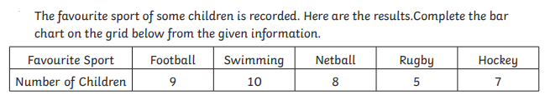

Maths- Silver
Use https://www.j2e.com/jit5#chart or Excel to create a bar chart to represent the data.
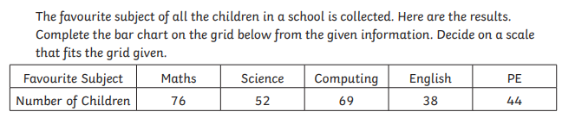
Maths- Gold
Use https://www.j2e.com/jit5#chart or Excel to create a bar chart to represent the data.
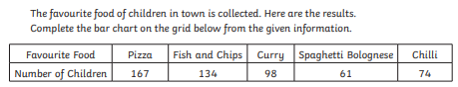

The Plant Life Cycle

