Please find todays learning tasks below.
The table below explains the tasks and you will find the resources underneath. Your child will know which challenge they usually access in each subject and which task will be appropriate for them.
Year group: 3 Date: 13th May
 | Bronze | Silver | Gold
English | Powerful verbs- Today we would like you to think of powerful verbs. Read each sentence and fill in each gap with a powerful verb which makes sense. You may use the verbs in the box below. Can you think of your own powerful verbs? | Powerful verbs- Today we would like you to up level the verbs to more powerful verbs. Please copy out the passage and up level the underlined verbs. You may use the verb box to help. Can you think of your own powerful verbs? | Powerful verbs- Today we would like you to up level the verbs to more powerful verbs. Please copy out the passage and up level the underlined verbs.
Maths | Please complete the bar graph using the given data. Use a ruler to make sure your graph is readable. | Draw a bar graph to represent the given data. Be careful when the data doesn’t match the scale exactly. | Complete the reasoning questions to complete the data. Then convert it to a bar graph to show it visually.
Reading/Spelling | Please follow the link below to access online reading books. Please see the list of books for your child’s reading band in their red book. https://www.oxfordowl.co.uk/  Please read at least 2 pages of a book and record it in the red school links book. Can you write the common exception word 3 times? Please see the tables on the next pages. These are the words for this week. You could even test yourself on Friday. (new words will be given next Monday)  We have attached some wordsearches for you to complete.
Other | Today’s subject focus will be Geography. Please read the information page about the Great Plains and then answer the questions. Some questions may require you to do your own research using the internet.
Unless otherwise specified , please complete the tasks in either your homework book or on a word document
Bronze- Spellings

Spelling | Write | Write | Write
find
kind
mind
behind
wild

Bronze- Spellings

Silver/Gold- Spellings

Spelling | Write | Write | Write
accident

business

centre

early

experiment

group

imagine

Silver/Gold- Spellings

English- Bronze
Read each sentence and fill in each gap with a powerful verb which makes sense. You may use the verbs in the bow below. Can you think of your own powerful verb?

English- Silver
Powerful verbs- Please copy out the passage, uplevel the underlined verbs with more powerful ones. You may use the ones in the box below. Try and think of at least 5 of your own.

English- Gold

Powerful verbs- Please copy out the passage, uplevel the underlined verbs with more powerful ones. You could use a thesaurus to help uplevel the verbs.

Maths- Bronze
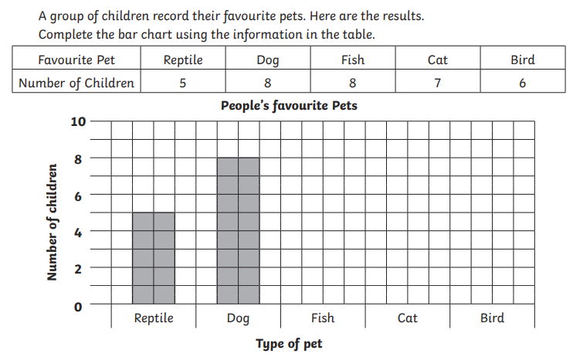
Maths- Silver
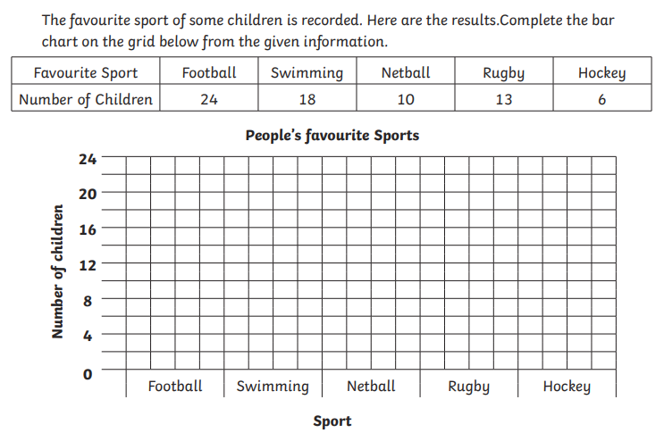
Maths- Gold
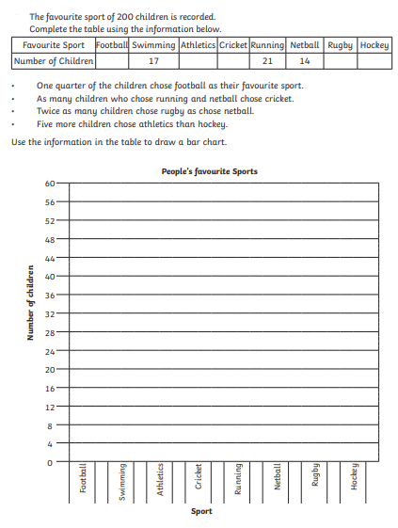

Topic
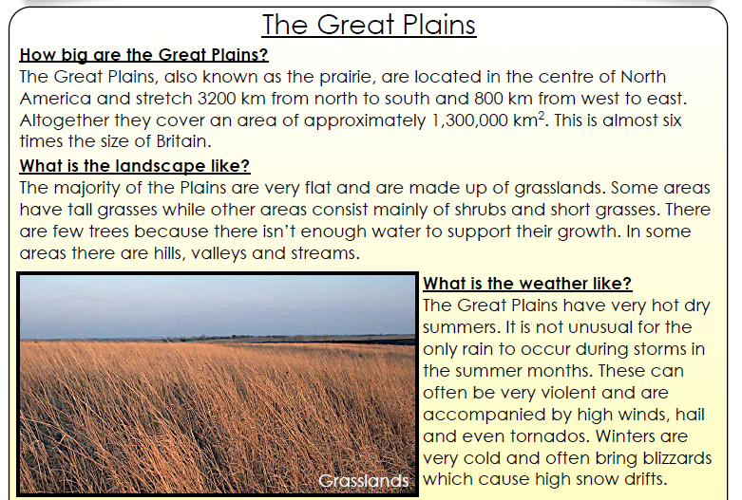
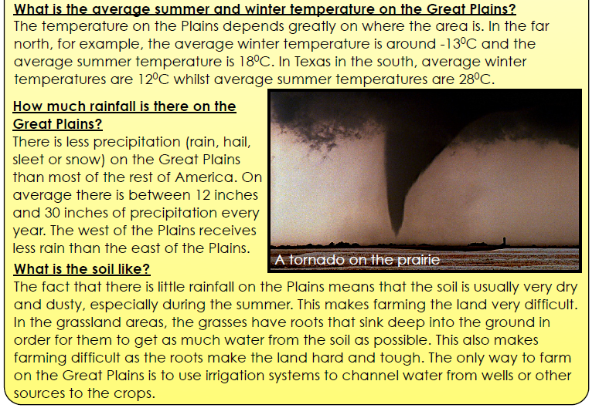

Bronze
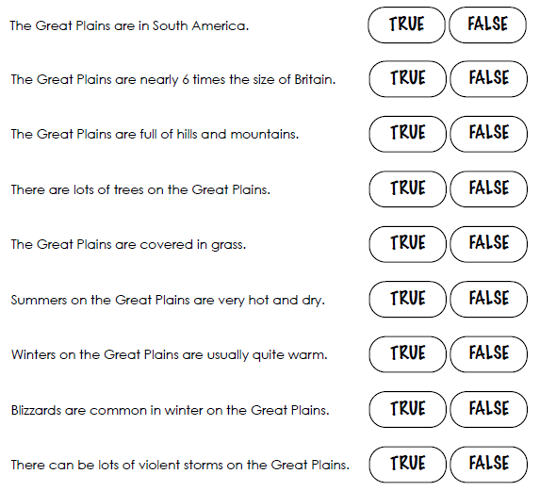

Silver
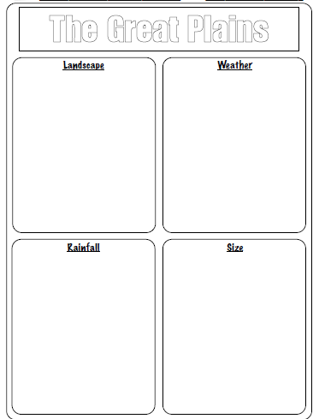

Gold
