Please find todays learning tasks below.
The table below explains the tasks and you will find the resources underneath. Your child will know which challenge they usually access in each subject and which task will be appropriate for them.
Year group: 3 Date: 12th May
 | Bronze | Silver | Gold
English | a or an? Today we would like you to log onto Education City and find the a or an Bronze- 12.05.20 activity. Please look at the help sheet below and complete the activity. | a or an? Today we would like you to use the poster below to help you understand when to use a or an. Then choose the correct word for each sentence and write the full sentence in your book. Don’t forget the challenge task. | a or an? Today we would like you to look at the help sheet below to explain when to use a or an. Read through the story, circle the mistakes and write the correct article above. Then write 3 of your own sentences including a or an.
Maths | Complete the tally to represent the numbers. Then answer the questions. | Complete the tally to represent the data. Then calculate the frequency and answer the questions. | Complete the tally to represent the data. Then calculate the frequency and answer the questions.
Reading/Spelling | Please follow the link below to access online reading books. Please see the list of books for your child’s reading band in their red book. https://www.oxfordowl.co.uk/  Please read at least 2 pages of a book and record it in the red school links book. Can you write the common exception word 3 times? Please see the tables on the next pages. These are the words for this week. You could even test yourself on Friday. (new words will be given next Monday)  Please try the SPAG activities attached.
Other | Today’s subject focus will be PSHRE- Please watch this video clip https://www.bbc.co.uk/bitesize/clips/zcw9wmn  Please create a poster about the importance of leading a healthy lifestyle. You could include top tips and pictures. You could also create your poster using a computer. Try and be as creative as you can.
Unless otherwise specified , please complete the tasks in either your homework book or on a word document
Bronze- Spellings

Spelling | Write | Write | Write
find
kind
mind
behind
wild

Silver/Gold- Spellings

Spelling | Write | Write | Write
accident

business

centre

early

experiment

group

imagine

SPAG- Bronze

SPAG- Silver

SPAG- Gold

English- Bronze
Please log onto Education City and watch the video. Then use the help sheet above to complete the activity.

English- Silver
Please use the help poster above and circle the correct word. Please write the sentence correctly in your yellow book. Then complete the challenge by writing sentences about the elephant and dragon using a and an correctly.

English- Gold
Task 1- Please use the help poster above and spot the mistakes. Circle the mistakes then write the correct article (a or an) above.
Task 2- Please write 3 of your own sentences which include a or an.

Maths- Bronze
Convert the numbers to a tally to show the number of children who like each colour.
Then answer the questions.
Use this video to help you https://youtu.be/6L2ch1esFGA .
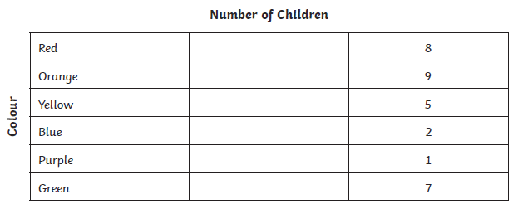

- Which is the most popular colour?
- Which is the least popular colour?
- What is the difference between the most and least popular?

Maths- Silver
30 children were asked what their favourite activity for a free afternoon at home would be. Here are their answers.
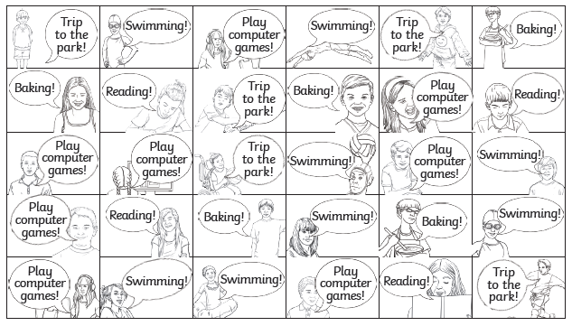
Convert the numbers to a tally and write the frequency.
Use this video to help you https://youtu.be/6L2ch1esFGA .
Activity | Tally | Frequency
Swimming
Trip to the park
Play computer games
Baking
Reading

- Which is the most popular activity?
- Which is the least popular activity?
- What is the difference between the most and least popular?

Maths- Gold
30 children were asked what their favourite activity for a free afternoon at home would be. Here are their answers.
Convert the numbers to a tally and write the frequency.
Use this video to help you https://youtu.be/6L2ch1esFGA .

- Which is the second-most popular activity?
- Which is the second-least popular activity?
- What is the difference between the most and least popular?
- How many more children like swimming that a trip to the park?
- Do more people like reading or playing computer games? Explain.

