Please find todays learning tasks below.
The table below explains the tasks and you will find the resources underneath. Your child will know which challenge they usually access in each subject and which task will be appropriate for them.
Year group: 3 Date: 11th May
 | Bronze | Silver | Gold
English | Comprehension- Please read the Horrid Henry and Moody Margaret text below. Answer the comprehension questions using the text to help. Remember to answer the questions with a sentence. | Comprehension- As it was VE day on Friday we would like you to read the text and answer the comprehension questions. Remember to answer the questions with full, clear sentences. | Comprehension- As it was VE day on Friday we would like you to read the text and answer the comprehension questions. Remember to answer the questions with full, clear sentences.
Maths | Use the pictogram with a scale of 1 to answer the questions. Try to answer in full sentences. | Use the pictogram with a scale of 2 to answer the questions. Try to answer in full sentences and look carefully at the scale. | Use the pictogram to answer the questions.  Pay close attention to the scale and try to answer in full sentences.
Reading/Spelling | Please follow the link below to access online reading books. Please see the list of books for your child’s reading band in their red book. https://www.oxfordowl.co.uk/  Please read at least 2 pages of a book and record it in the red school links book. Can you write the common exception word 3 times? Please see the tables on the next pages. These are the words for this week. You could even test yourself on Friday. (new words will be given next Monday)
Other | Today’s subject focus will be PE- Today we would like you to try the WOW Active challenges. We have attached the challenge card below. Enjoy!
Unless otherwise specified , please complete the tasks in either your homework book or on a word document
Bronze- Spellings

Spelling | Write | Write | Write
find
kind
mind
behind
wild

Silver/Gold- Spellings

Spelling | Write | Write | Write
accident

business

centre

early

experiment

group

imagine

English- Bronze
Please read the passage and answer the questions in sentences.
Horrid Henry and Moody Margaret
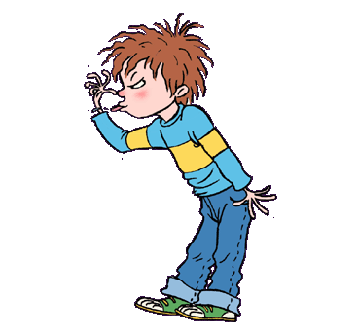
“I’m Captain Hook!”
“No, I’m Captain Hook!”
“I’m Captain Hook,” said Horrid Henry.
“I’m Captain Hook” said Moody Margaret.
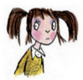
They glared at each other. “It’s my hook,” said Moody Margaret.
Moody Margaret lived next door. She did not like Horrid Henry, and Horrid Henry did not like her. But when Rude Ralph was busy, Clever Clare had flu, and Sour Susan was her enemy, Margaret would quickly jump over the wall to play with Henry.
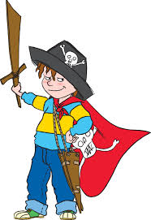
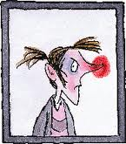
“Actually, it’s my turn to be Hook now,” said Perfect Peter. “I’ve been the prisoner for such a long time.”
“Prisoner, be quiet! Said Henry.
“Prisoner, walk the plank!” said Margaret.
“But I’ve walked fourteen times already,” said Peter. “Please can I be Hook now?”
“No, by thunder!” said Moody Margaret. “Now out of my way, worm!” And she swashbuckled across the deck, madly waving her hook and clutching her shiny sword and dagger.
Margaret had eye patches and skulls and crossbones and plumed hats and cutlasses and sabres and snickersnees.
Henry had a stick. This was why Henry played with Margaret. But Henry had to do terrible things before playing with Margaret’s amazing swords. Sometimes he had to play ‘Mums and Dads’ with her. Worst of all (please don’t tell anyone), sometimes he had to be the silly baby.
Henry never knew what Margaret would do. When he put a spider on her arm, Margaret laughed. When he pulled her hair, Margaret pulled his harder. When Henry screamed, Margaret would scream louder. Or she would sing. Or pretend not to hear. Sometimes Margaret was fun. But most of the time she was a moody old grouch.

Bronze- Comprehension questions
- Who did Moody Margaret and Horrid Henry both want to be?
__________________________________________________________
__________________________________________________________
- Moody Margaret only played with Horrid Henry when who else was busy?
__________________________________________________________
__________________________________________________________
- What was Perfect Peter pretending to be?
__________________________________________________________
__________________________________________________________
- What had Perfect Peter done 14 times?
__________________________________________________________
__________________________________________________________
- What do you think swashbuckled means?
__________________________________________________________
_________________________________________________________
- What did Moody Margaret do when Henry put a spider on her arm?
__________________________________________________________
__________________________________________________________
- Underline the adjective in this sentence:
“No, by thunder!” said Moody Margaret. “Now out of my way, worm!” And she swashbuckled across the deck, waving hook and clutching her sword and dagger.
- Read the following sentence again:
“It’s my hook,” said Moody Margaret.
Why do you think my is in bold?
____________________________________________________________
_____________________________________________________________________________
English- Silver: Page 1

English Silver- Page 2

English- Silver questions

English- Gold Page 1

English- Gold Page 2

English- Gold questions 1

English- Gold questions 2

Maths- Bronze
The following pictogram shows the number of hours spent playing video games by 6 children in a week. Can you answer the questions?
Each screen represents 1 hour.
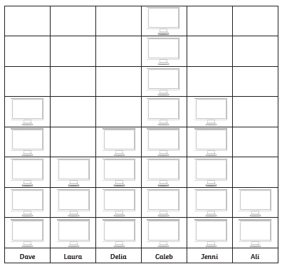
- Who played video games for the longest?
- What is the difference in hours between the person who played the least and most?
- Who played for longer? Boys or girls?
- How many children spent less than 3 hours playing?
- What was the total number of hours played?

Maths- Silver
The following pictogram shows the number of hours spent playing video games by 6 children in a week. Can you answer the questions?
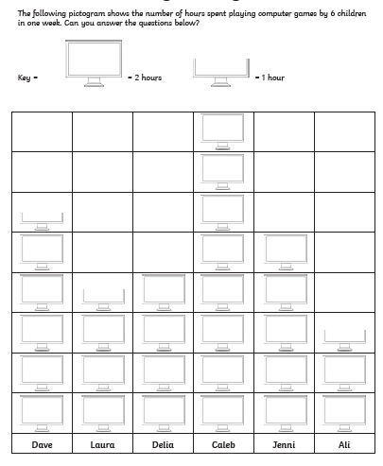

- Who played video games for the longest?
- What is the difference in hours between the person who played the least and most?
- Who played for longer? Boys or girls?
- How many children spent less than 8 hours playing?
- What was the total number of hours played?

Maths- Gold
The following pictogram shows the number of hours spent playing video games by 6 children in a week. Can you answer the questions?

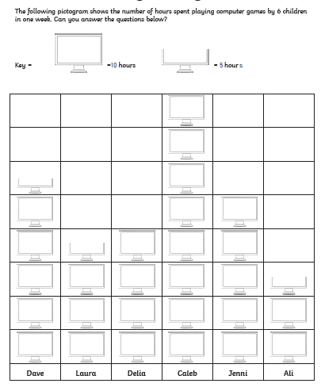
- Who played video games for the longest?
- What is the difference in hours between the person who played the least and most?
- Who played for longer? Boys or girls?
- How many children spent less than 10 hours playing?
- How many children spent less than 20 hours playing?
- What was the total number of hours played?
PE
Please try these activities. You could get your family to join in with you.
Have fun!

