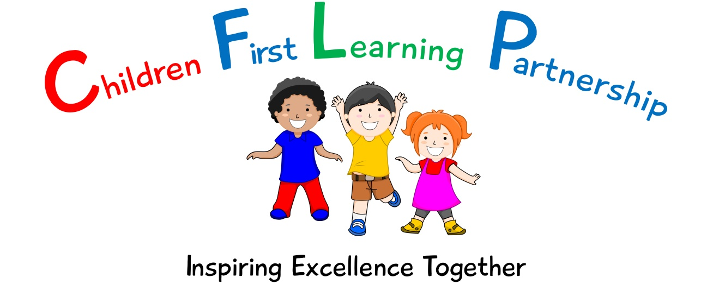

English Policy 2020

February 2022 or earlier if required
To be reviewed:
03.02.2020
Agreed and ratified by the Local Advisory Board on:
Headteacher – Mrs E Goodyear

Responsible Officer:
Mr. C Clulow
Chair of Local Advisory Board:
The CFLP English Policy in respect of the Children First Learning Partnership has been discussed and adopted by the Local Advisory Board.

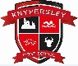
Knypersley First School
English Policy 2020
(To be read in conjunction with the school handwriting and spelling policies)

The overall intent of our school curriculum is to:
Recognise uniqueness: in our pupils, staff, resources and whole school community.
Be Inclusive: recognising learning styles, learning needs at all levels and providing solutions to any barriers to learning we encounter.
Engage and Inspire: Through knowledge rich, highly enriched, progressive and purposeful contexts.
Promote Aspiration: offering challenge, accountability and responsibility for their learning.
Create citizens of the Future: who thrive on responsibility, see difference as a strength of our community and use democracy to embed their own values and beliefs.
Our English curriculum strives to drive all of these intentions and links very closely to the achievement and development of them all.
Intent
Our challenging and creative English curriculum aims to enable all pupils to achieve ambitious levels of literacy. Children are provided with an exciting and innovative curriculum which promotes a love of reading and a belief that everybody is an author.
Children are exposed to high quality literature to inspire their own writing and to model engaging uses of the English language. Through the critique of these texts, children develop their oral comprehension skills. Imagination and originality are nurtured through exploration, discussion and drama. Spelling, punctuation, grammar and phonics teaching ensure that children have the skills and confidence to develop their writing style across a range of genres and in varied contexts.
We recognise the importance of communication and language development in achieving academic success in English. Therefore, oracy is at the heart of our curriculum. Children are immersed in a language rich curriculum that intends to give all pupils an extensive vocabulary and oral proficiency.
Implementation
We use the National Curriculum programmes of study for Reading, Writing, Spelling, Grammar and Punctuation. We ensure that basic literacy skills are entwined through our text based units and the wider curriculum.
We deliver phonics through a systematic and synthetic approach, based largely on the Letters and Sounds document which is adapted to the needs of individual cohorts. (Please see appendix 2, phonic progression document) We introduce exploration and teaching of Common Exception Words (CEW) alongside phonics so that our children gain the skills necessary for early reading.
Reading is an integral part of school life and our school uses a mix of phonically decodable, reading scheme and real books to support children’s development. This is delivered through individual, group and whole class teaching sessions using challenging texts to apply new skills and knowledge taught. (Please see Appendix 1 for our Reading band and Phonic Phase link document)
Reading for Pleasure
Our children deserve a rich curriculum that encourages a love of literature. All classes share books (in their entirety where possible) and are given access to a wide range of texts across different subjects. We believe that active encouragement of reading for pleasure is a core part of every child's educational entitlement, because we know that extensive reading and exposure to books makes a huge contribution to children’s vocabulary, understanding and subject knowledge. Reading is promoted through the use of our school libraries, class reading areas and whole school assemblies.
Spellings are explored, taught and practised regularly and are commented upon during marking conferences and live facilitation to ensure our high expectations are met. Children have a mixture of CEW and spelling patterns to learn on a weekly basis.
Writing
The medium term plans show progression of writing skills across the school. At Children First Learning Partnership children are taught a range of genres to embed the basic skills across the curriculum.
Lessons are planned from the correct year groups Programmes of Study from The National Curriculum. Teachers will be aware of the prior learning that needs to be secure from previous year groups to ensure new content can be understood. The medium term plans are then broken down into smaller steps to ensure lessons are driven by sharp learning objectives that are progressively linked. We use our flow of writing (See Appendix 3) to support the learning process and to practise and embed new skills and knowledge in the different genres.

Individual lessons are carefully designed using the most effective teaching materials, so that pupils are given the best opportunities to show their understanding. Variation is consciously built in by teachers, so that pupils can apply their learning to different genres and make cross curricular links.

We use pre cursive and cursive handwriting throughout the school. Staff teach the formation of letters specifically in the EYFS alongside phonics, saying a rhyme to aid memory and follow the schools progression document for formation and joins. (See Appendix 4)

English Language
Across the Children First Learning Partnership we understand that the English technical language is crucial to children’s thinking. So we introduce new words from the curriculum through text based units and WAGOLLs. Key vocabulary used in a text based unit/genre are displayed on the English working walls.
In lessons children work in a variety of ways including pairs; whole class, groups and individually. Children work together so that through their dialogue they can develop a much stronger understanding.

All adults model the correct use of technical language and insist pupils do the same, including correct use of standard English language.

Pitch, Pace and Challenge
Across the Children First Learning Partnership the expectation is that the majority of children will move through the units at broadly the same pace. However, decisions about when to progress will always be based on the security of children’s understanding and their readiness to progress to the next stage. Children will be taught analytical strategies which helps the children comprehend unfamiliar content.
Editing
Pupils are encouraged to develop a ‘have a go’ attitude and are comfortable with making mistakes, as they are seen as part of the learning process. Children have the opportunity to edit and improve their work.

Basic Skills
Embedding of basic skills within reading and writing and using the writing toolkit, will enable pupils to accelerate their learning and close any gaps.
Impact-
What we aim to achieve from our English curriculum across the Children’s First Learning Partnership;
- Children will have a love of reading and a belief that everybody is an author.
- Children will have creative minds and build imagination and originality.
- Children will be secure in basic skills including SPAG and phonics.
- Children will have an extensive vocabulary and oral proficiency.
- Children will read and write for pleasure.
- Children will work collaboratively and independently to share ideas.
Assessment -
Our impact will be measured by using both formative and summative assessment.
Formative
Assessment is not just used to track children’s learning through the use of assessment ladders but also provides teachers with up-to-date and accurate information about the specifics of what children do and do not know. This information allows teachers to adapt their teaching so it builds on children’s existing knowledge and focuses on the next steps that they need in order to make progress.
Within the Children First Learning Partnership, assessment in English is continuous. From the beginning of every lesson, teachers and teaching assistants will be assessing prior knowledge through assessment for learning to identify the current stage and next steps in learning. Staff will facilitate to ensure that misconceptions are dealt with immediately and high attaining children are challenged appropriately. Our staff are highly skilled to provide a personalised and flexible curriculum for individual children that may need reasonable adjustments. These adaptations increase access to the lesson content, enabling them to reach their full potential.

Effective marking and feedback are an important element of teachers and TAs responses to children’s learning. This may be given either orally during live marking or in written format during a marking conference, but is always:
- specific, accurate, and clear
- celebrates success
- compares what a pupil is doing right now with what they have needed to improve before
- provides specific guidance on how to improve as their next step
Summative
As part of our assessment and to support teacher’s judgements, each class will undertake a half termly formal assessment of SPAG and phonics. This is then converted and analysed through scaled scores which are evaluated termly by English leaders and acted upon quickly to direct CPD, resources and support to help pupils to overcome barriers to learning or from reaching their full potential.
Role of Leaders
- Plan an effective and varied schedule of monitoring including moderation, so that the Quality of Education in English is embedded throughout the school.
- Respond quickly and in a supportive manner to overcome barriers to implementation and impact.
- Use assessment information to provide effective CPD and challenge.
- Provide clear updates to the Local Advisory Board, Headteacher and SLT.

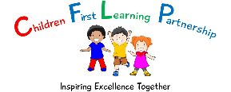
Appendix1

Book Band | Teacher assessment | Revised Phonic Order -Year group | Phonics stage (L&S document)
Pearl (free) | 5D and beyond
Diamond | 5E
Sapphire | 4S
Emerald | 4D
Ruby | 4E
Topaz | 3S
Copper | 3D
Lime | 3E
White | 2S
Gold | 2D
Purple | 2E | Y2 | Phase 6
Turquoise | 1S/2E | Y1 & Y2 | Phase 5
Orange | 1S | Y1 | Phase 5
Green | 1D | Y1 | Phase 5
Blue | 1E | RC & Y1 | Phase 3 & alternatives from 5
Yellow | RS/1E | RC & Y1 | Phase 3 & alternatives from 5
Red | RD/RS | RC | Phase 2
Pink | RE/RD | RC | Phase 2

Phase 4 incorporated into revised phonic order in Reception

Appendix 2
Phonic progression
Phase | Typical Year group | Graphemes/phonemes | CEW |  | Decodable HFW
1 | Nursery | Playing with sounds  Rhyming  Alliteration  ORAL blending and segmenting –revisit often and saturate
2 | Reception | CVC, CCVC, CVCC, CCVCC and CCCVCC  s a t p i n  m d o g  c, k, ck  e u r  h, b f, ff, l, ll, ss  Teach consonant blends after single sounds  For example pl, st, cr, fl, mp, nd (see page 126 in letters & Sounds)  ORAL blending is key here – lots and lots of practice please. Stay on Phase 2 for longer | the  to  I  no  go  into  he  she  we  be  me  was |  | A  An  As  At  If  In  Is  It  Of  Off  On  Can  Dad  Had  Children  Just  pull | Back  And  Get  Big  Him  His  Not  Got  Up  Mum  But  Put  Went  It’s  from  help  full
3 and 5 mixed | Reception & Y1 | j g (gem) v w wh x y(yes)  z zz s(hens) qu f ff ph sh ch (chef) c k ck ch (school)  ch tch th (both) th (this) ng ai ay a-e ee ea e-e ie e (delay) y  igh ie i-e i (mind) y oa ow oe o-e ou (mould) o (cold) oo ew (stew) ue (blue & cue) ou (you) u-e (huge &brute) u (unit) oo u ar a (father)  or aw au(launch) ore ur er ir ow ou oi oy air  s ss c (cell) e ea (head) ear ure | Has  You  They  All  Are  My  Her  Said  Have  Like  So  Do  Some  Come  Were  There  Little  One  When  Out  What | Oh  Their  People  Mr  Mrs  Looked  Called  Asked  Could  Where  Today  Love  Once  Friend  School  Our | Will  That  This  Then  Them  With  See  For  Now  Down  Look  Too  Push | Don’t  Old  By  I’m  Time  House  About  Your  Day  Made  Came  Make  Here  Saw  Very
5 | Y1 Y2 | j g dge mb n kn gn r wr s c (cell) sc (science)  sh t (ion) ss (ion, ure) c (ion, ious, ial) v ve i (ee) y ey eo ai eigh ey ei oo ui  oo(u) oul or al our ur ear or our e ear ere eer air are ear  ure our er  Revise previously learned graphemes for each phoneme to ‘hook’ new learning onto.u  For a bank of words see page 154 of letters and sounds | Door  Floor  Poor  Because  Climb  Every  Everybody  Even  Pretty  Great  Break  Steak  Beautiful  Hour  Move  Prove  Improve  Sure  Sugar  Eye  Could  Should  Would  Who  Whole  Any  Many  Clothes | Busy  water  again  half  money  parents  Christmas | Please refer to the next 200 common words in Letter and Sounds.

Appendix 3
Flow of writing

Prior Learning | Explore | Develop | Dazzle Me
- List the features  - Sorting activity – sentences, extracts  - Spider diagram  - Comparison of two texts – Non fiction,fiction  - Cold write  - Odd one out – Which one is the letter?  - Tense of language  - Bad WAGOLL – Spot the mistakes | - Identify features, highlighting  - WAGOLLs  - Drama – hot seating, conscience alley, retell role play, small world re-enactment  - Story mapping  - Sequencing  - Freeze framing  - Piecing together | - Planning  - Skills and sentences  - Writing elements of the genre  - Exploring skills  - Writing a full piece of genre – retells, twists, own versions  - Up-level/improve group/teachers version  - Guided writing | - Edit,  - Redraft  - Up-level language – thesaurus, wordbank, resources  - Up-level spellings – dictionaries, zap its  - Peer assessment  - Self assessement against criteria

Appendix 4
Handwriting Progression

